**9. ReactJS-HOL**

**Listofplayers.js:**

import React from "react";

function ListofPlayers({ players }) {

  return (

    <ul>

      {players.map((item, index) => (

        <li key={index}>

          Mr. {item.name} - {item.score}

        </li>

      ))}

    </ul>

  );

}

**export default ListofPlayers;**

**IndianPlayers.js:**

import React from "react";

function IndianPlayers() {

  const IndianTeam = ["Sachin", "Dhoni", "Virat", "Rohit", "Yuvaraj", "Raina"];

  const oddPlayers = IndianTeam.filter((_, index) => index % 2 === 0);

  const evenPlayers = IndianTeam.filter((_, index) => index % 2 !== 0);

  const T20players = ["Virat", "Rohit", "Bumrah"];

  const RanjiTrophyPlayers = ["Pujara", "Rahane", "Ishant"];

  const mergedPlayers = [...T20players, ...RanjiTrophyPlayers];

  return (

    <div>

      <h2>Odd Players</h2>

      {oddPlayers.map((player, index) => (

        <div key={index}>{player}</div>

      ))}

      <hr />

      <h2>Even Players</h2>

      {evenPlayers.map((player, index) => (

        <div key={index}>{player}</div>

      ))}

      <hr />

      <h2>List of Indian Players Merged</h2>

      {mergedPlayers.map((player, index) => (

        <div key={index}>{player}</div>

      ))}

    </div>

  );

}

export default IndianPlayers;

**ListofIndianPlayers.js:**

import React from "react";

function ListofIndianPlayers({ IndianPlayers }) {

  return (

    <ul>

      {IndianPlayers.map((item, index) => (

        <li key={index}>Mr. {item}</li>

      ))}

    </ul>

  );

}

export default ListofIndianPlayers;

**App.js:**

import React from "react";

// Players array for flag = true

const players = [

  { name: "Jack", score: 50 },

  { name: "Michael", score: 70 },

  { name: "John", score: 40 },

  { name: "Ann", score: 61 },

  { name: "Elisabeth", score: 61 },

  { name: "Sachin", score: 95 },

  { name: "Dhoni", score: 100 },

  { name: "Virat", score: 84 },

  { name: "Jadeja", score: 64 },

  { name: "Raina", score: 75 },

  { name: "Rohit", score: 80 },

];

// Indian team for flag = false

const IndianTeam = ["Sachin", "Dhoni", "Virat", "Rohit", "Yuvaraj", "Raina"];

// Odd players logic

function OddPlayers(players) {

  return (

    <div>

      <h1>Odd Players</h1>

      <ul>

        <li>First: {players[0]}</li>

        <li>Third: {players[2]}</li>

        <li>Fifth: {players[4]}</li>

      </ul>

    </div>

  );

}

// Even players logic

function EvenPlayers(players) {

  return (

    <div>

      <h1>Even Players</h1>

      <ul>

        <li>Second: {players[1]}</li>

        <li>Fourth: {players[3]}</li>

        <li>Sixth: {players[5]}</li>

      </ul>

    </div>

  );

}

// Merged Indian players

function ListofIndianPlayers() {

  const IndianPlayers = [

    "First Player",

    "Second Player",

    "Third Player",

    "Fourth Player",

    "Fifth Player",

    "Sixth Player",

  ];

  return (

    <div>

      <h1>List of Indian Players Merged:</h1>

      <ul>

        {IndianPlayers.map((player, index) => (

          <li key={index}>Mr. {player}</li>

        ))}

      </ul>

    </div>

  );

}

// List all players with scores

function ListofPlayers({ players }) {

  return (

    <div>

      <h1>List of Players</h1>

      <ul>

        {players.map((player, index) => (

          <li key={index}>

            Mr. {player.name} {player.score}

          </li>

        ))}

      </ul>

    </div>

  );

}

// Filter players with score <= 70

function Scorebelow70({ players }) {

  const filtered = players.filter(player => player.score < 70);

  return (

    <div>

      <h1>List of Players having Scores Less than 70</h1>

      <ul>

        {filtered.map((player, index) => (

          <li key={index}>

            Mr. {player.name} {player.score}

          </li>

        ))}

      </ul>

    </div>

  );

}

// Main app logic

function App() {

  const flag = true; // Change to true/false to test

  if (flag === true) {

    return (

      <div>

        <ListofPlayers players={players} />

        <Scorebelow70 players={players} />

      </div>

    );

  } else {

    return (

      <div>

        {OddPlayers(IndianTeam)}

        <hr/>

        {EvenPlayers(IndianTeam)}

        <hr />

        <ListofIndianPlayers />

      </div>

    );

  }

}

export default App;

**Output:**

When flag = true

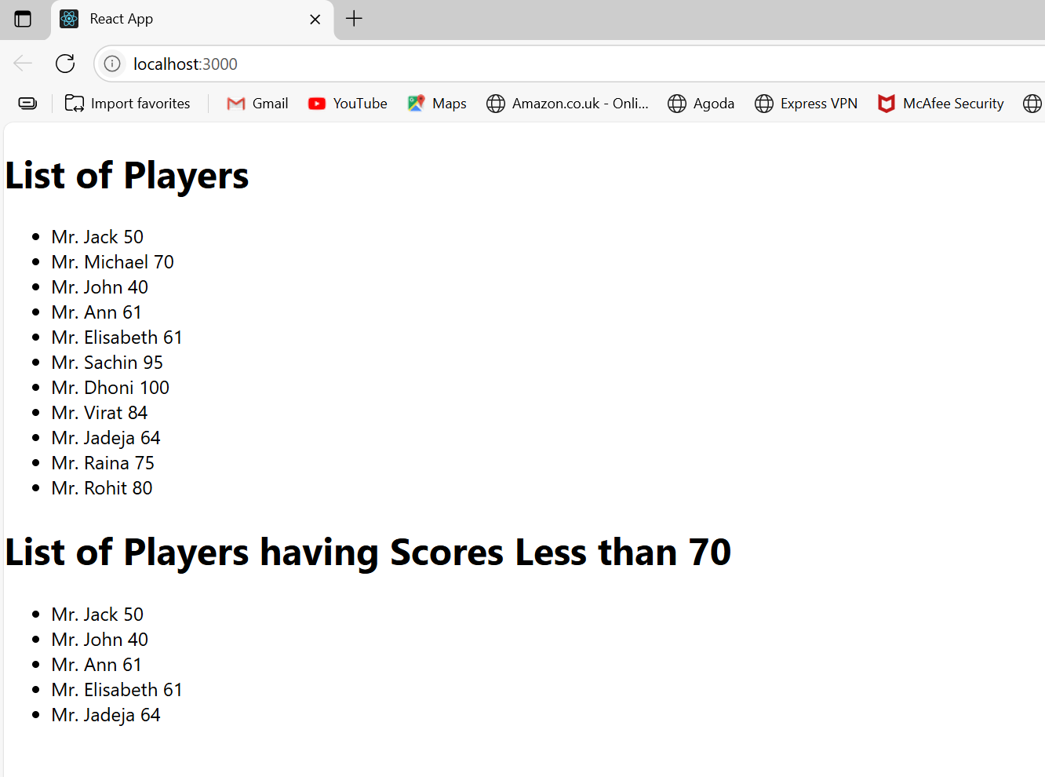

When flag = false;

